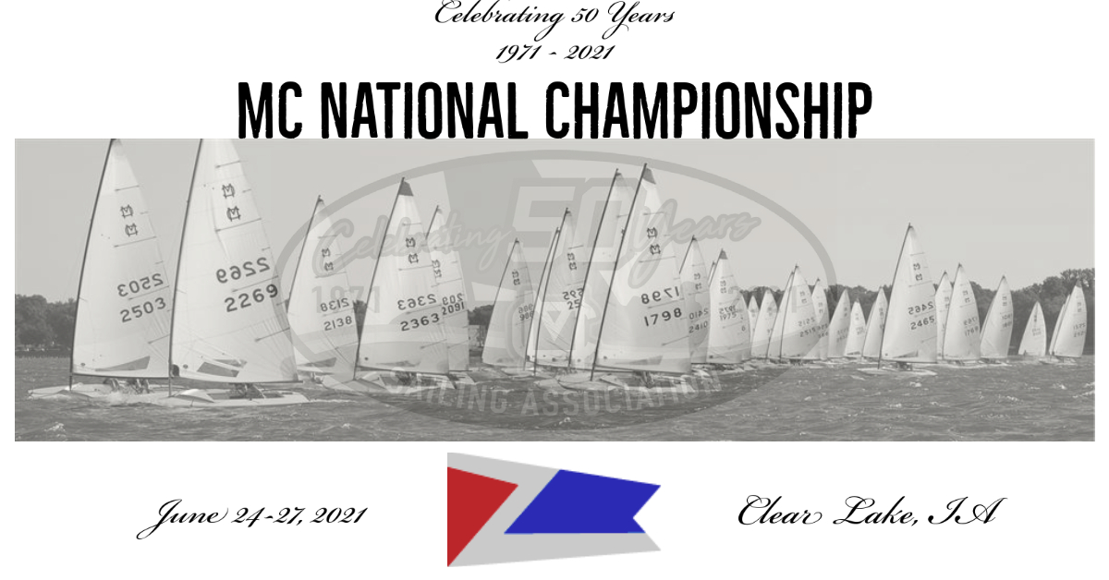
We welcome you to beautiful Clear Lake, Iowa – situated close to the Northern border of Iowa, 20 miles south of Minnesota, Clear Lake is a spring fed, glacial lake sitting higher than the surrounding flat land. Our lake is regarded as one of the best Inland venues for sailboat racing; Host of 4 previous MC National Championship regattas, including the largest MC National Regatta ever held (yr 2000 - 109 boats).
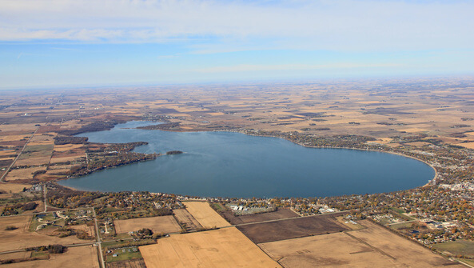
Included in the packet is the COVID-19 Protocol, Notice of Race, Social Venue highlights and much more valuable information regarding our slice of sailing heaven.
Traveling to Clear Lake
Clear Lake is conveniently located off Interstate 35 and the Avenue of the Saints (Iowa 27/US 18) in Northern Iowa. We are the mid-point between Des Moines, Iowa and Minneapolis/St. Paul.
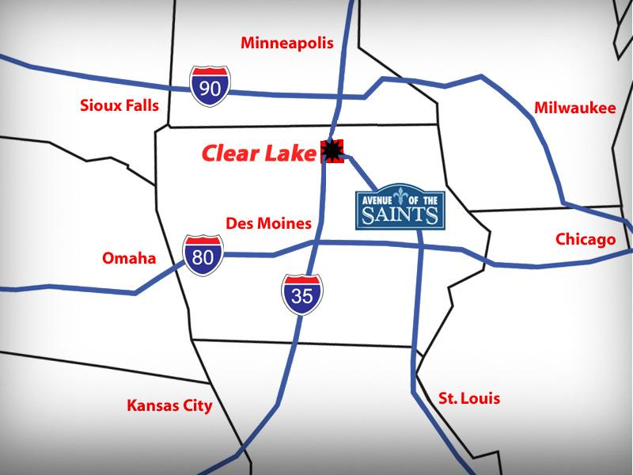
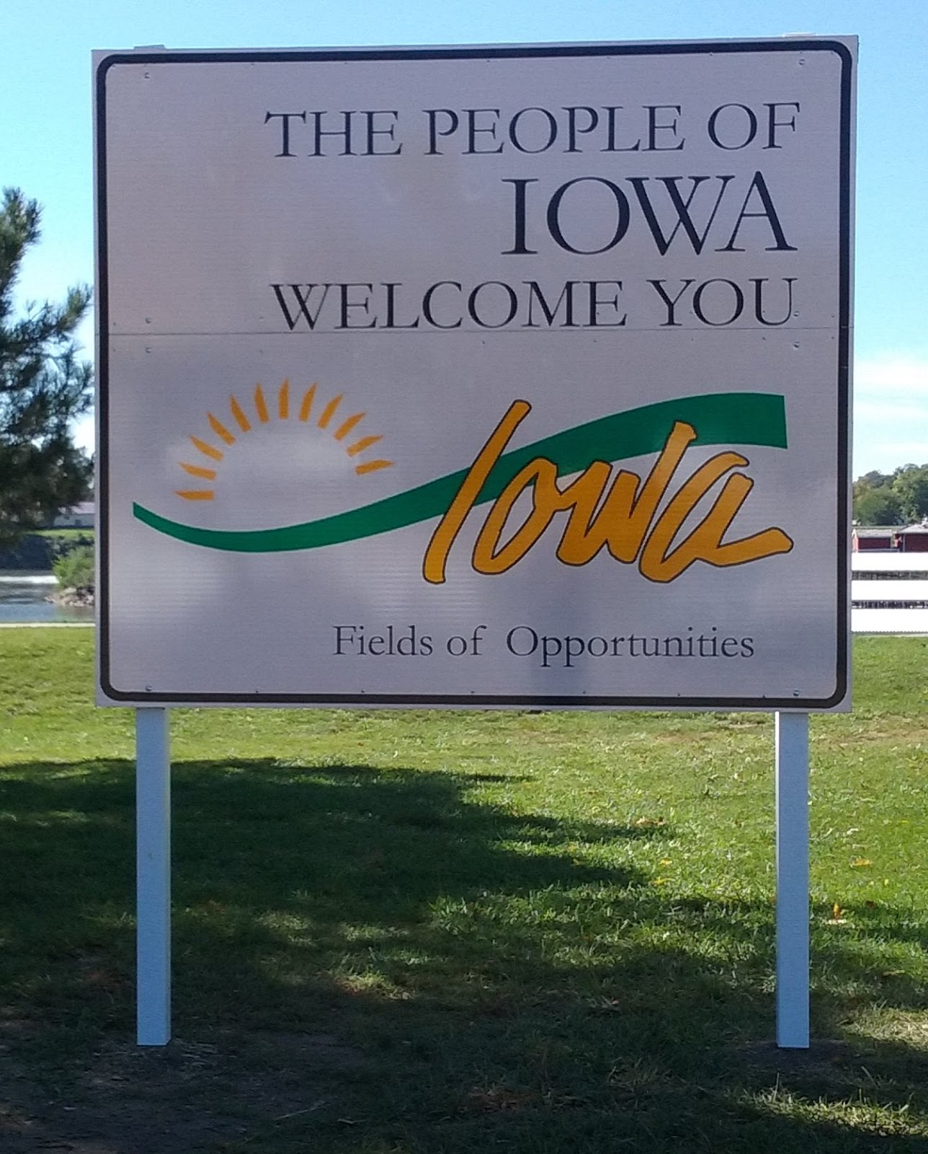

COVID-19 Response

General
The Clear Lake Yacht Club will follow the recommended guidelines in place at the time of the regatta from the Iowa Department of Public Health, Iowa Department of Natural Resources and Federal CDC guidelines or requirements as applicable.
Use of the CLYC Clubhouse
- While the clubhouse will be open, the interior of the clubhouse, generally, will not be used for this regatta and it is expected that all participants, when gathering, will do so outside and under the tent that will be on the CLYC grounds
- Bathrooms will be available for use throughout the regatta
- Hand sanitizing solution and wipes will be placed throughout the building and in the bathrooms. In addition, these products will be available outside during the registration / check-in process, boat launch / take out and lunches
- Commonly handled items like door knobs, faucets, slider doors, etc. will be wiped down periodically during the day and at the end of the day before the clubhouse is closed throughout the regatta

Onsite Registration
- Registration will be done outside. CLYC will provide 2 people that will facilitate the check-in and registration process. Both individuals will be wearing a face covering
- Hand sanitizing solution and wipes will be available on the tables being used or nearby

Boat Launching / Haul Out
- There will be a prescribed process for haul out to limit congestion and gathering at the ramp area and will be communicated to the participants during the check-in and registration process

Competitors Briefing
- The competitors briefing will be conducted at the yacht club facility and broadcast on VHF channel 72.
Dry Sailing - Mooring - Placement of Boats
- Dry sailing of boats will be on a first come, first served basis at the club facility and spots are limited
- Dry sailing at the Lakeside Inn will be reserved for those staying at this location
- All other boats will be moored or cross tied at private residences near the sailing area
- You may also make arrangements with friends and/or family to keep your boat at their private residence

Lunches
- All lunches will be individually packed and provided to participants outside the CLYC clubhouse prior to each day’s racing and during the lunch period as determined by the Race Committee
- For those wishing to eat at the CLYC, they will be directed to the tent area where tables will be appropriately spaced. Hand sanitizer and/or wipes will be available in the tent area

Evening Events
- The 2 evening events scheduled will be held at venues suitable to allow for maximum social distancing
- Tables and seating will be spaced in compliance with the current State of Iowa and CDC recommendations

Housing
- The CLYC, as regatta host, will not be providing any assistance with housing. Each participant is expected to make their own arrangements so that they can adhere to their own comfort level of social interaction
- Please visit clearlakeiowa.com for information on local hotels or use your favorite booking site. Many great hotels, motels and Airbnb options are available
- Please visit travelnorthiowa.com for information or here for the visitors guide. You will also receive visitor information at regatta check-in.
- If camping, we suggest you stay at the Clear Lake State Park https://www.iowadnr.gov/Places-to-Go/State-Parks/Iowa-State-Parks/Clear-Lake-State-Park

Spectator / Crew Boats
- All boats will be provided with hand sanitizer and wipes for use by the participants and wiped down after each disembarkment
- Boats will not be filled to capacity to allow for social distancing by onboard guests
- Boat drivers will be instructed to be flexible and sensitive to individuals who may feel uncomfortable while onboard
- If required/recommended by the CDC and IDPH, face coverings may be required by passengers while onboard

Protest Hearings
- Protest hearings will be conducted at the CLYC clubhouse in a manner reflective of guidelines in place at the time of the regatta
- All tables and chairs will be spaced in compliance with the current State of Iowa and CDC recommendations
- Face coverings will be required by all in attendance

Trophy Presentation
- The trophy presentations will be conducted outside the CLYC clubhouse under the tent or nearby

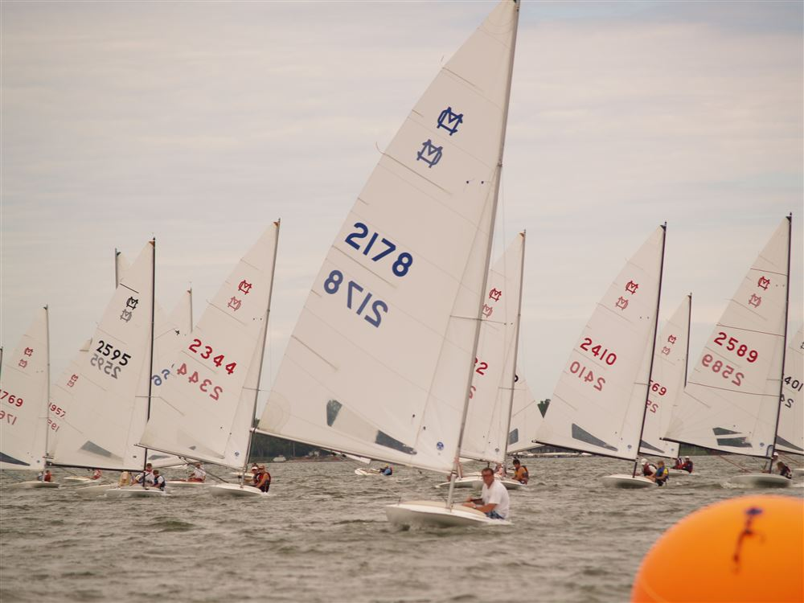

Notice of Race
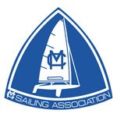 | MC Fleet #36 and the Clear Lake Yacht Club cordially invite you to the  MCSA 50th National Championship Regatta  June 24 - 27, 2021  Notice of Race
Venue | Clear Lake Yacht Club, 103 Main Ave, Clear Lake, IA 50428  The Clear Lake Chamber of Commerce sponsors a street event on Thursday evenings with street vendors and bands from 6:00-9:00 pm. So, when arriving on Thursday, please avoid Main Ave since it will be blocked. There will be signs to help direct traffic.  If arriving from the North or the South, exit I-35 at the northern Clear Lake exit (exit 194, Highway 18 West), go west to 8th street and turn south. Go to 1st Ave N and turn west and proceed towards the lake. This will take you directly to the staging area for rigging your boat.
Entries and  Eligibility | This is an MC Sailing Association (MCSA) sanctioned event. It is open to skippers of MC scows who are current members of MCSA. Each skipper must be a current member of MCSA and meet trophy age requirements before the first scheduled race. Non-MCSA members will be scored DNC for all races.  All yachts must comply with the MC class rules prior to the preparatory signal of the first scheduled race. A boat may sail with a different sail number from its hull number if it registers with that sail number, and must compete with that number for the entire event.  Each skipper must declare his/her age and will compete in the associated division.  - Open  - Masters - 50 - 59 years  - Grand Master - 60 - 69 years  - Mega Master - 70 -79 years  - Old Salt - 80 years or older  - Youth  - Woman  - Single Handed  Member Signup / Information
- Covid- 19 | This event will follow the Iowa Department of Public Health, Iowa Department of Natural Resources, and Federal CDC guidelines or requirements as applicable. The CLYC will make every effort to make this a safe and enjoyable event. Please see the separate Covid-19 Response document for more details on what the MCSA and CLYC will be doing to limit participants’ exposure to Covid-19.  2021 MC National Regatta COVID-19 Response & Procedures
Rules | The organizing authority (OA) for this regatta is the MC Sailing Association (MCSA) in cooperation with the Clear Lake Yacht Club (CLYC).  The regatta will be governed by the rules as defined in The Racing Rules of Sailing, Appendix S, and the MCSA rules and by-laws.  - The racing area at Clear Lake will be in the middle of the east end of Clear Lake, straight out from the yacht club.  - The sailing instructions will consist of the instructions in RRS Appendix S, Standard Sailing Instructions, and supplementary sailing instructions that will be published here, and be posted on the official notice board located at the club.  - Racing rules 30.1, 35, 41, 62.1, 62.2, A2, A4.2, A5, A10, and A11 will be changed. The changes will appear in full in the sailing instructions. The sailing instructions may also change other racing rules.  - Courses to be sailed are all windward leeward courses as shown in the Sailing Instructions.  - VHF Radio (72) will be used by the RC to communicate with competitors on the water. Additional instructions regarding radio communication will be included in the SI’s.  - Competitors give absolute right and permission for video footage or photographs of themselves or their boat generated during an MCSA event to be published in any media authorized by MCSA for press, editorial or advertising purposes.  - Safety Suggestion: MCSA encourages but does not require the use of masthead flotation panels when conditions warrant their use.  - Protest & Redress Information for Competitors  - 2021 MCSA Nationals Sailing Instructions
Scoring & Trophies | The Low Point System of RRS Appendix A will apply.  When fewer than 7 races are completed, a boat’s series score will be the total of her race scores. When 7 or more races are completed, a boat’s score will be the total of her scores excluding her worst score. This changes RRS A2.1.  Seven Races are scheduled. Three races need to be completed before a National Champion is recognized and perpetual trophies awarded. One race constitutes a regatta for purposes of awarding keeper trophies. Awards will be based on her finishes in the overall fleet.  Keeper Trophies:  - Top 15 Overall (any age, male or female)  - Top 3 Masters (50 - 59 years of age)  - Top 3 Grand Masters (60 - 69 years of age)  - Top Mega Master (70 - 79 years of age)  - Top Old Salt (80+ years of age)  - Top Woman-any age  - Top Youth (under 25 on June 25)  - Top Single-Handed Sailor  Address for return of previously won Perpetual Trophies:  Mark Tesar  705 North Shore Drive  Clear Lake, IA 50428
Schedule of  Events | NOTE: All times shown are preliminary. Check official Notice Board for updates.  Races will be scheduled at the discretion of the race committee to permit the completion of seven races.  Date Time Event  Thursday June 24 12:00- 8:00pm Check in & On-site registration. Avoid the rush the next morning. Come early and setup tonight!  3:00pm Optional Practice Race  Friday June 25 7:00-9:00 am Check in & On-site registration. Continental Breakfast (tentative)  8:30 am Welcome & Competitors Briefing (VHF Channel 72 only)  10:00am Warning signal for first race of the day  TBD Racing as conditions permit  TBD Lunch  TBD Racing begins as Directed on Notice Board by the PRO  6:30 pm Social Event at the Surf Ballroom  Saturday June 26 7:30- 9:30 Continental Breakfast (tentative)  TBD Racing begins as Directed on Notice Board by the PRO  TBD Racing as conditions permit  TBD Lunch  TBD Racing begins as Directed on Notice Board by the PRO  6:30 pm Annual Membership Meeting & Cocktail Party with heavy hors d'oeuvres & open bar at: Jeff Brakke’s house 1929 North Shore Drive, Clear Lake  Sunday June 27 7:30- 9:30 Continental Breakfast (tentative)  TBD Racing begins as directed on Notice Board; If three races have been completed no warning signal will be made after 1200 hours. If three races have not been completed this time limit is extended to 1500 hours. No warning signal shall be made after 1500.  TBD Lunch & Trophy Presentation at CLYC
Registration | Please login to MSCA to register. The registration link will appear in the upper right hand corner.  Please PAY AT THE EVENT, not on-line. Credit cards accepted at the event location.  2021 MCSA 50th National Championship - Competitor's Packet  Registration closes at 9:00 am on Friday, June 25.  Boat Registration:  $195 ea If you register by June 11 , $205 afterwards.  $ 65 ea Youth entry (under age 25 on June 25) Youth MCSA Membership is Free  Skipper Registration fee entitles each registrant to:  - Complimentary Continental Breakfasts for all attendees.  - Three Lunches  - Friday & Saturday Night Dinner/Cocktail Parties.  - Regatta T-Shirt ( Long or Short sleeve).  - 50th Commemorative Craft Beer Glass for all Skippers.  $80 ea - Additional Package of all Meals: (3) lunches, (1) Friday social event, (1) Saturday social event.  $10 ea - Additional Lunch  $30 ea- Additional Friday Social event  $30 ea- Additional Saturday Social event  $35 ea- Additional Shirt. Please pre-order at early registration (before June 9th). Extra shirts at the event is not guaranteed.
Apparel | You have a choice of a long sleeve quarter zip or a short sleeve T-shirt for the Regatta Shirt.  Regatta Shirts ordered by June 9 will be available at registration. Regatta Shirts ordered after June 10 may be available for your size onsite. If not, then they will be re-ordered and mailed to you. There will be a limited quantity of shirts for sale onsite at the regatta on first come first serve basis.
Launching/  Mooring | Launching will be using the two boat ramps at the CLYC.  Boats will be assigned to a CLYC member dock for cross-tying. We have arranged for some parking spaces where boats can be dry-sailed from their trailer. We have some spots by the CLYC building downtown and some spots next to the ramp by the Lakeside Inn only for people staying at the Lakeside Inn. If dry-sailing, you will be responsible for your own launching and hauling out of your boat.  If you are staying at the Lakeside Inn and would like to dry-sail from that area, please let us know during online registration so we don’t assign you to a member dock.  If you would like to keep your boat on its trailer by the CLYC building, also please let us know during online registration. Those spots will be handed out on a first-come basis.  If you have made your own arrangements for dock space, please let us know that too so we don’t assign you to a member dock.  Trailer parking will be at a designated parking lot approximately 10 blocks from the CLYC. Directions / signs will be in place to direct the drive to the parking lot.
Accommodations
Due to the current concerns over Covid-19, the CLYC will not be providing or assisting with any housing requests. Participants are encouraged to seek their own accommodations. If camping, we suggest you stay at the Clear Lake State Park https://www.iowadnr.gov/Places-to-Go/State-Parks/Iowa-State-Parks/Clear-Lake-State-Park

If you are interested in lodging, click here for a good listing of local establishments.
Questions | Regatta Chairs:  Mark Tesar, mtesar@cltel.net, 641-529-0747.  Stu Oltrogge, oltrogge@clyciowa.com, 651-295-4913.  Dan Allen, dsallen@cltel.net, 641-430-8847.  Phone number at club: 641-357-8001
Disclaimer of Liability | Competitors participate in the regatta entirely at their own risk. See RRS4, Decision to Race. The organizing authority will not accept any liability for material damage or personal injury or death sustained in conjunction with or prior to, during, or after the regatta.
Copyright Notice | This event, website, and its content is copyright of MC Sailing Association, Inc. - © MC Sailing Association, Inc. 2021. All rights reserved.  Any redistribution or reproduction of part or all of the contents in any form is prohibited other than the following:  - you may print or download to a local hard disk extracts for your personal and non-commercial use only  - you may copy the content to individual third parties for their personal use, but only if you acknowledge the website as the source of the material  You may not, except with our express written permission, distribute or commercially exploit the content. Nor may you transmit it or store it in any other website or other form of electronic retrieval system.

Regatta Welcome Thursday at the CLYC
Downtown Clear Lake
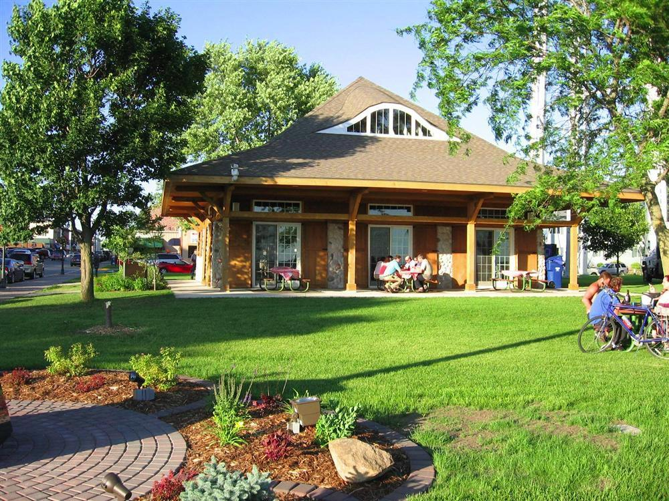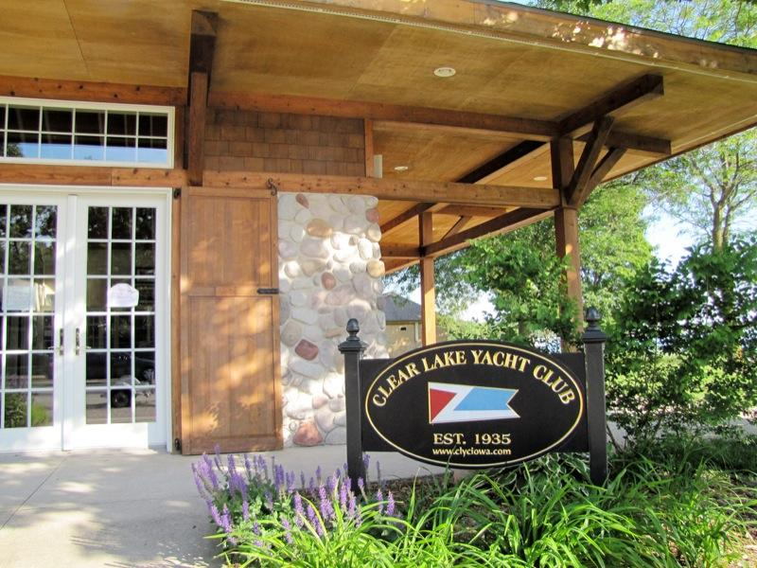

Situated downtown between the City Park and City Beach at water’s edge; the CLYC has a long heritage in the area. Established in 1935 by a group of sailing enthusiasts who fostered a resounding enthusiasm through the years. Clear Lake’s downtown area became home in the early 90’s, a new clubhouse was built and eventually dedicated in 2002; it’s main purpose is as a learning facility for the Clear Lake Sailing Center while also hosting club social gatherings, general club meetings as well as outside events.
We will have refreshments available throughout registration. Please take some time to tour Clear Lake’s charming downtown area and enjoy the great things it has to offer.
www.clyciowa.com
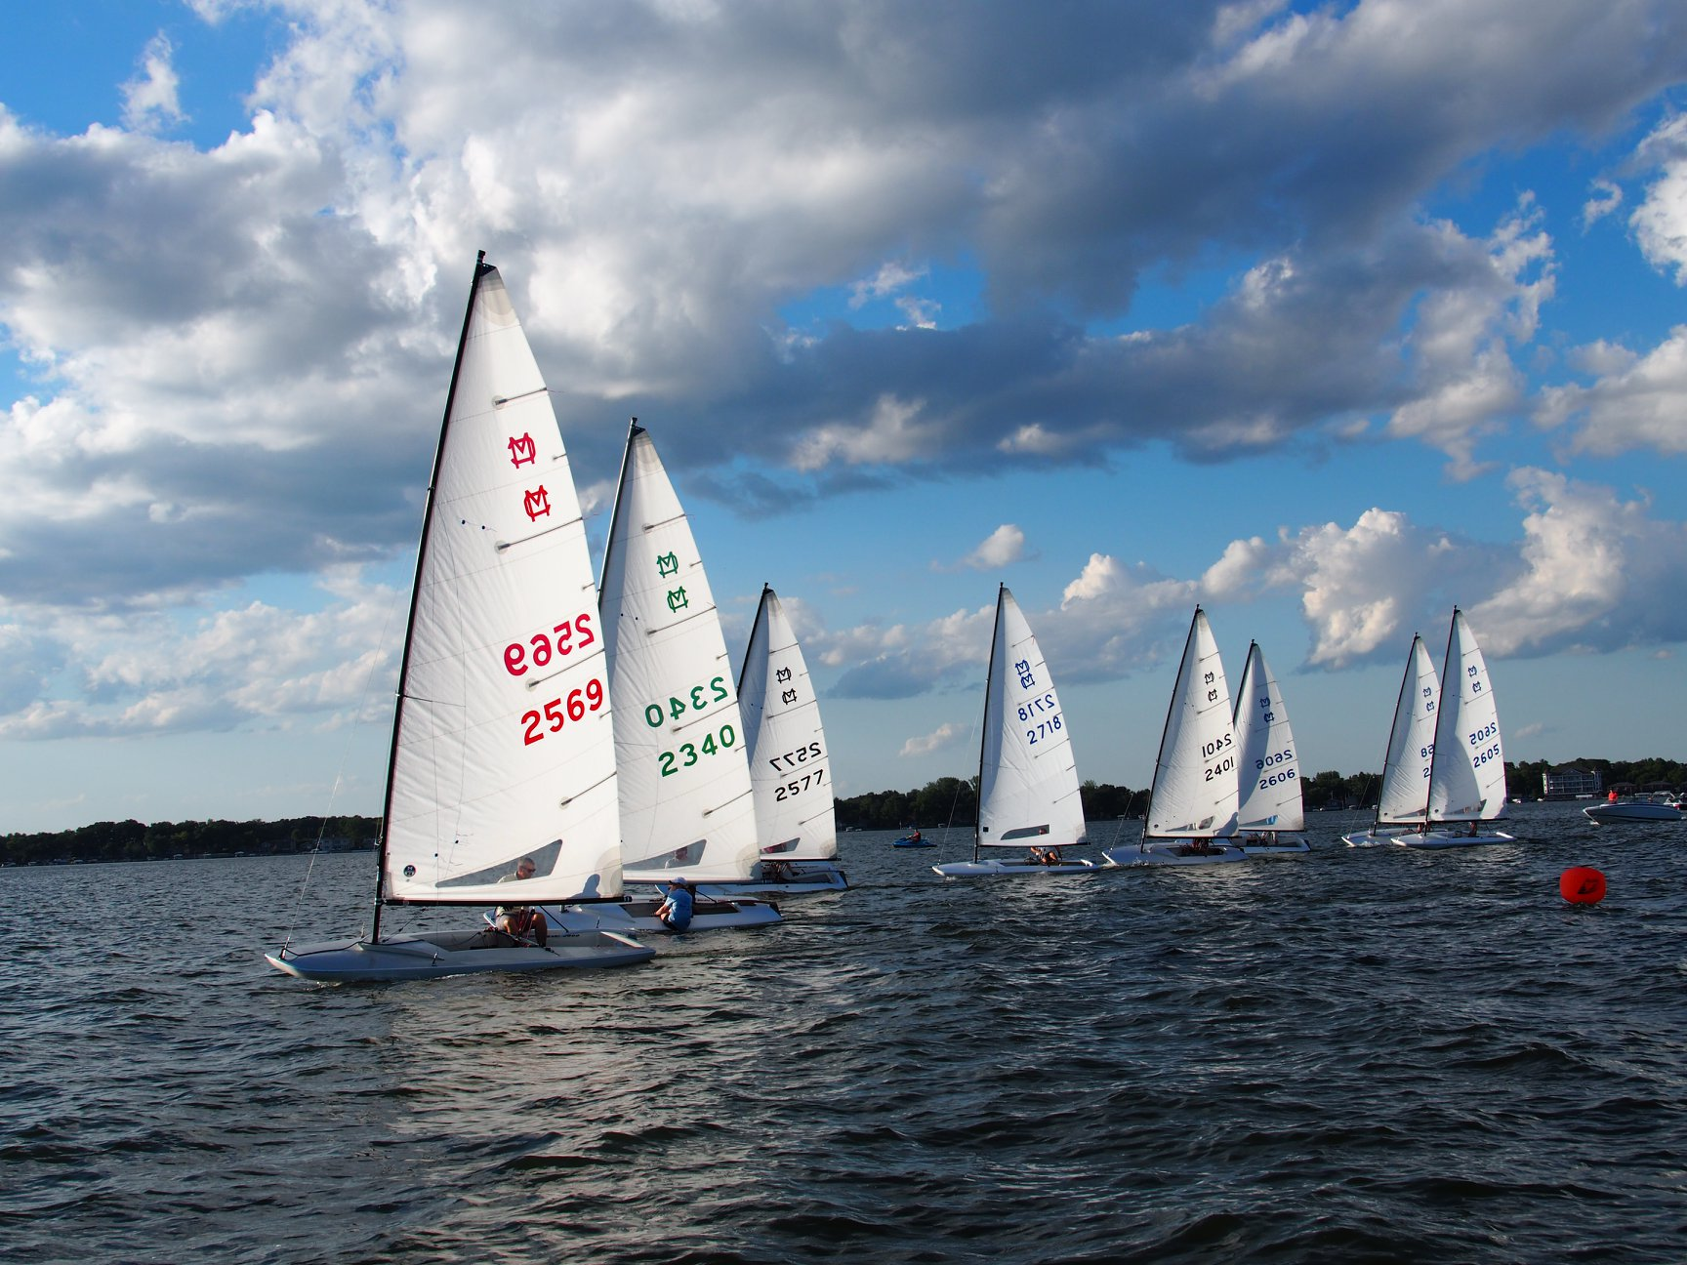
Friday Night at the Surf Ballroom
460 North Shore Dr, Clear Lake

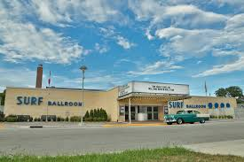
Friday evening after racing we will have dinner and entertainment at the Surf Ballroom.
The legendary Surf Ballroom is the location of the annual Winter Dance Party in February; it commemorates the last concert by Buddy Holly, Ritchie Valens and the Big Bopper. Many music legends have played the venue through the years, all listing the Surf as one of the best touring spots to entertain.

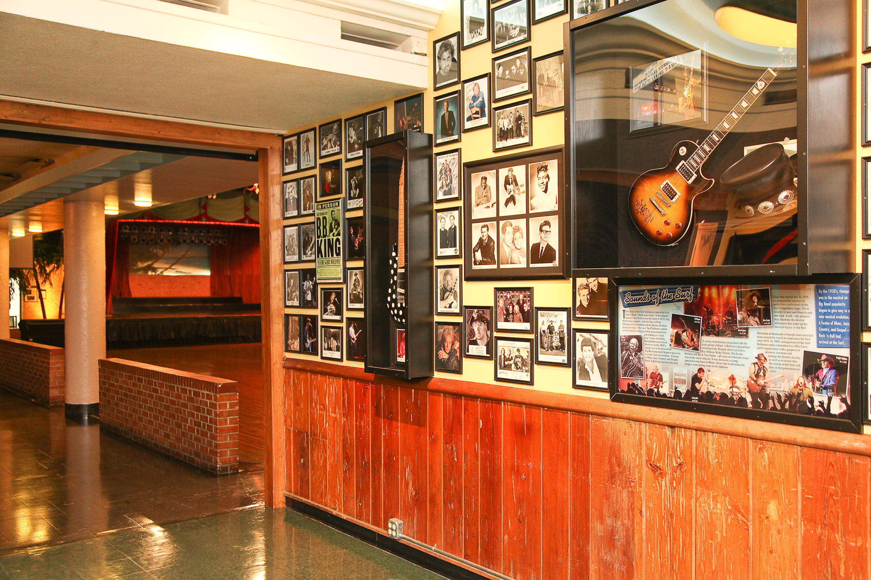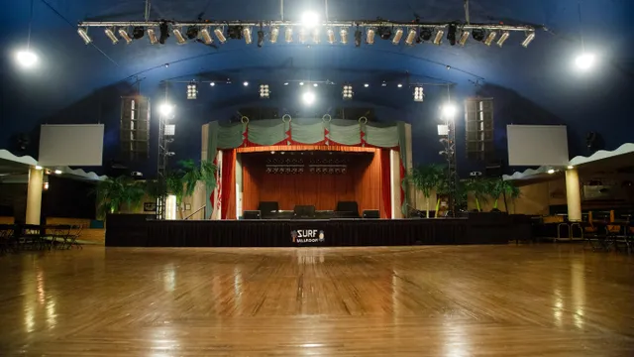
www.surfballroom.com

Saturday Night at Jeff Brakke’s Residence
1929 North Shore Drive, Clear Lake

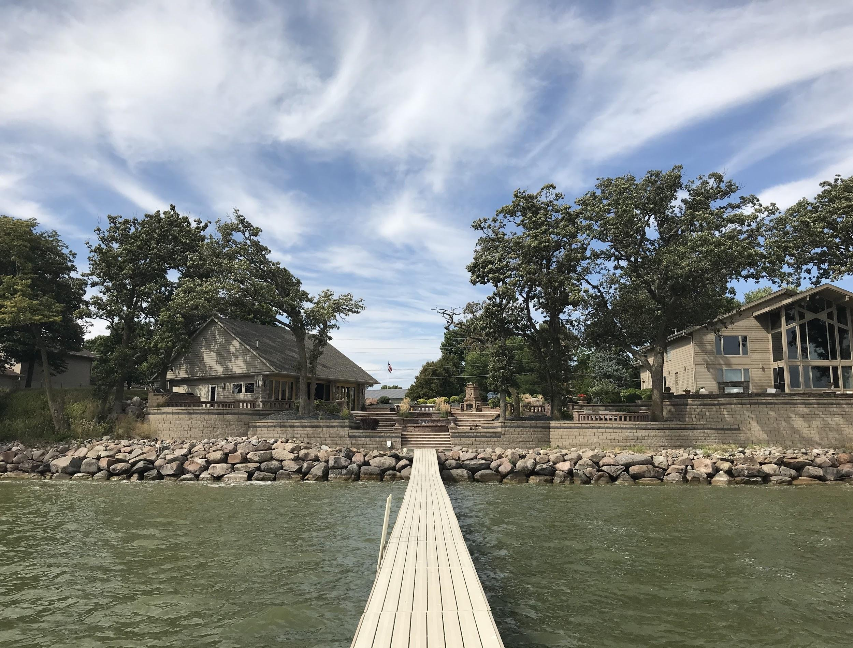
Rebuilt in 2014, Jeff’s Brakke’s residence is truly one of a kind on Clear Lake. 180 feet of lake frontage, 4 tiers of patio area, multiple fire and water features are just the start. The property has a second building made for hosting parties just like this! It features a full bar, fireplace and many seating areas; this is a true Clear Lake gem.
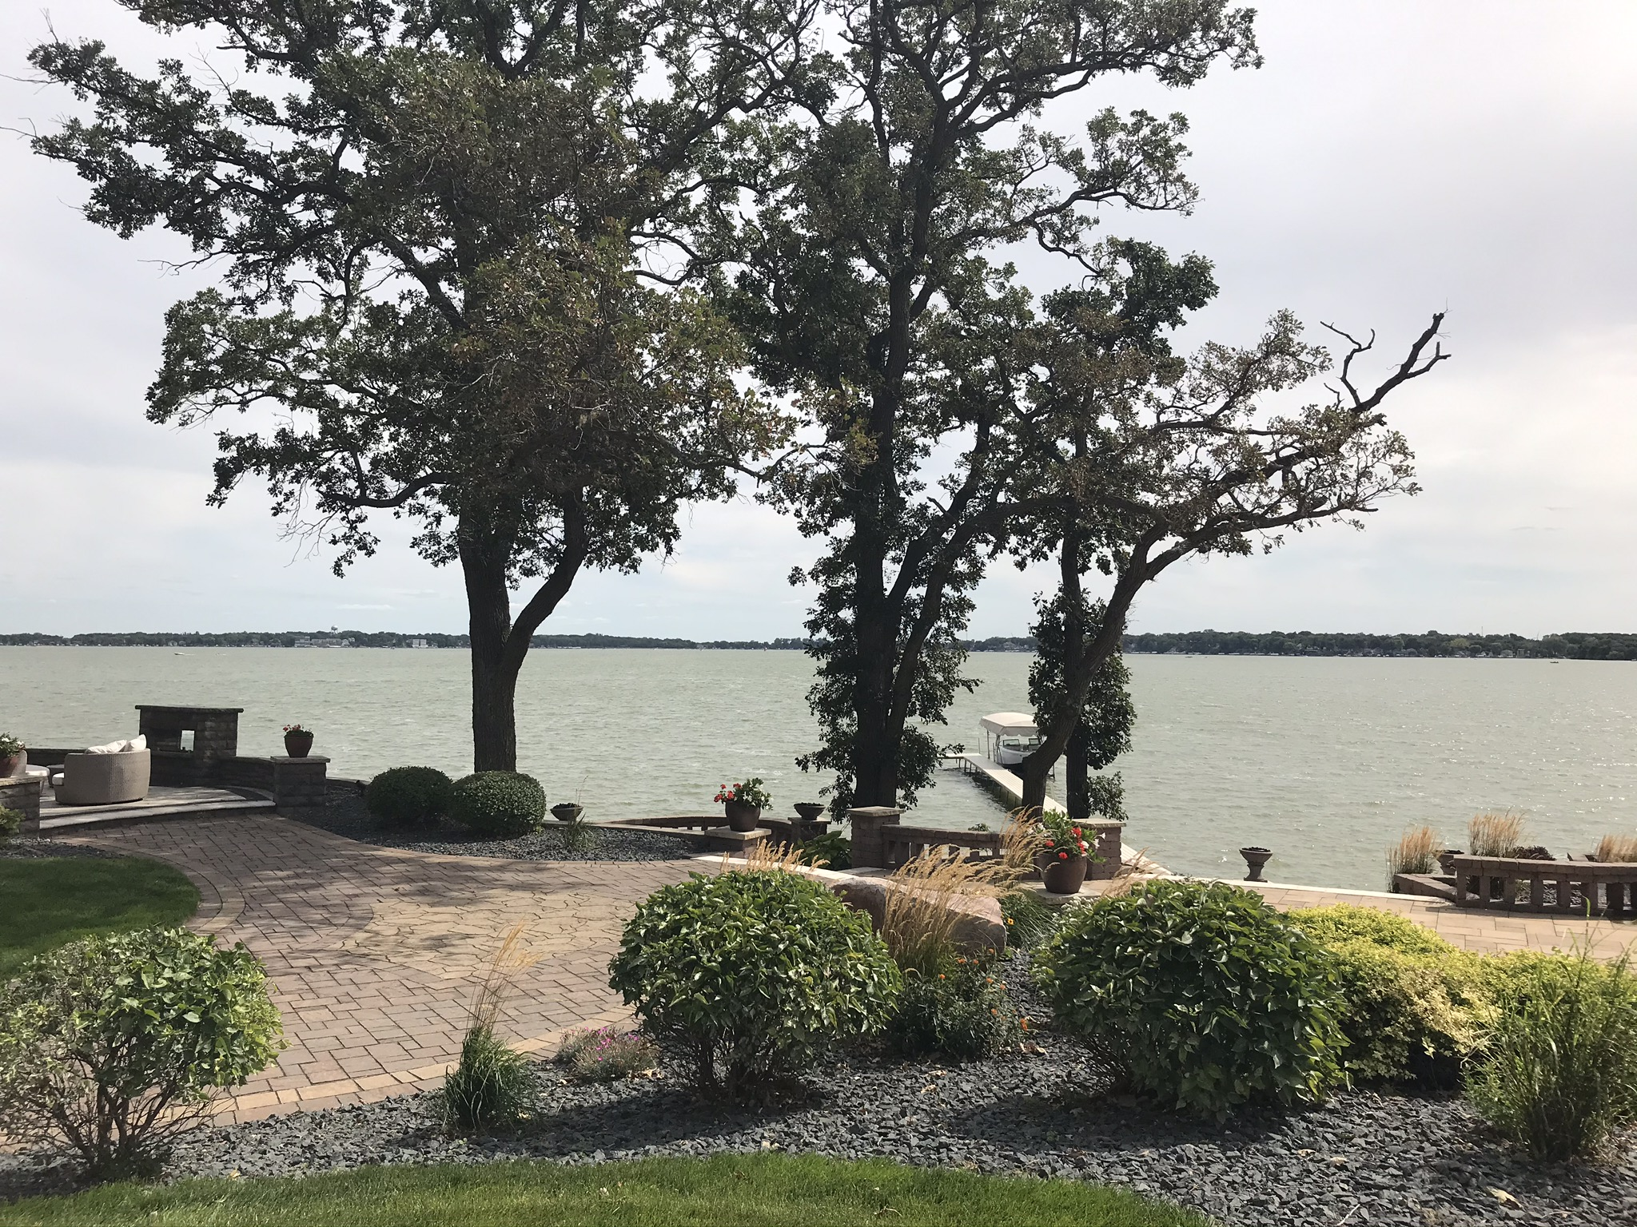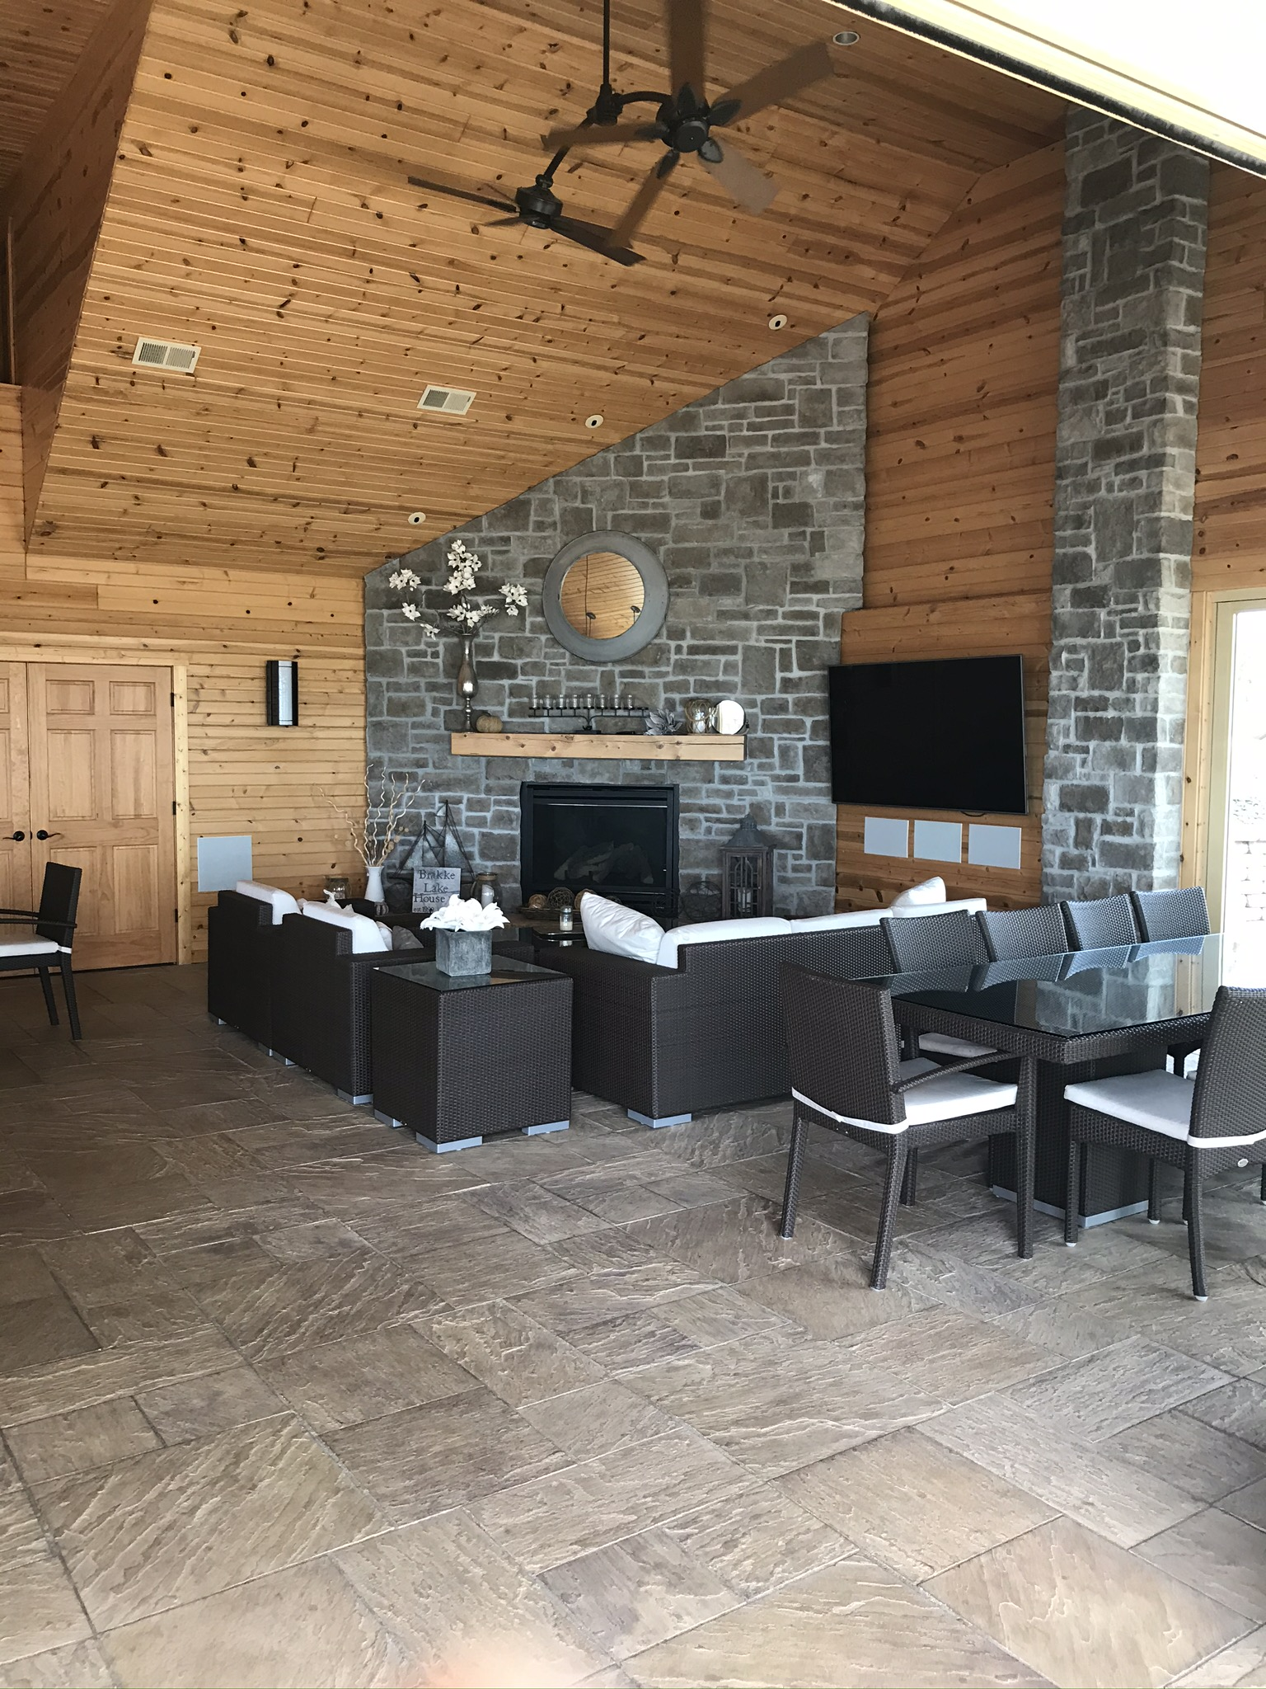

Presentations related to the 50 years of MC sailing will be scattered around the grounds; a raffle benefiting the Clear Lake Sailing Center will be held, then after dinner the MCSA Annual Meeting will be called to order by Commodore Scott Harestad.
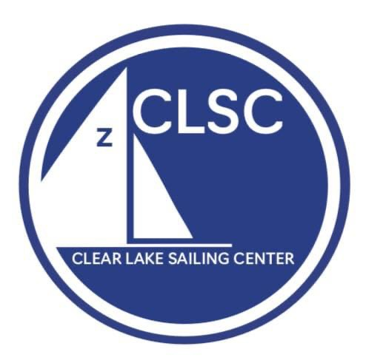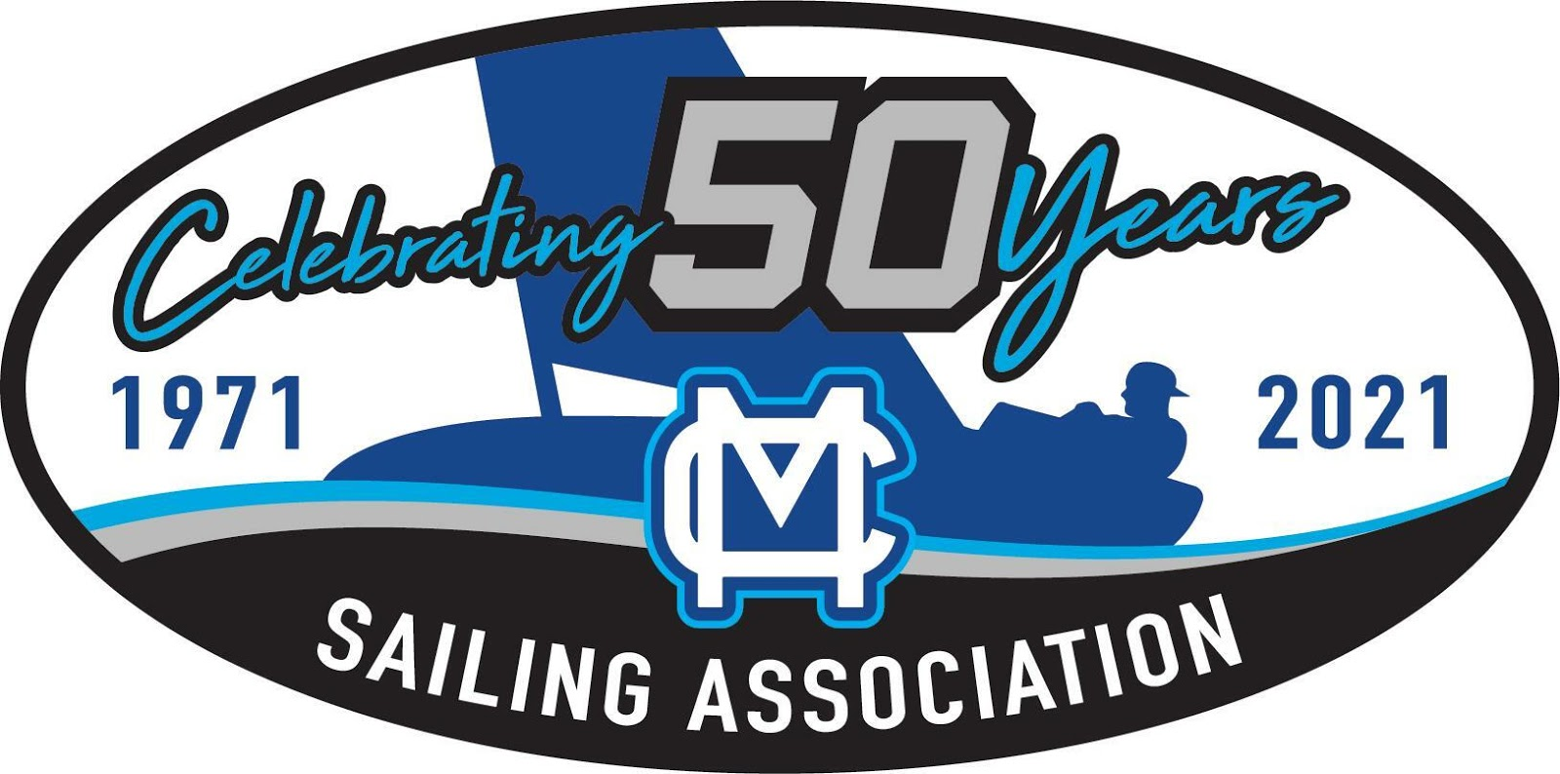
Raffle Benefiting the Clear Lake Sailing Center (501c3)
The Clear Lake Sailing Center located in downtown Clear Lake, cultures enthusiasm and teaches sailing to people of all ages. From our youngest sailors starting in Optimists to adults learning in various classes the Sailing Center promotes more than just a love for sailing, it teaches valuable life skills for the students to take with them.
You must attend the regatta to purchase tickets and be present at the social event to win.
Thanks to our valued donors; here are several items to be raffled:
- Draheim Performance XP Mainsail
- Mad Sails Mainsail (Cut of your choice)
- North Sails Magnum Mainsail
- Quantum Sails Powerzone Mainsail
- UK Sailmakers PS2 Mainsail
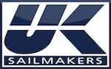
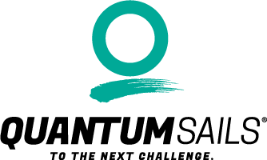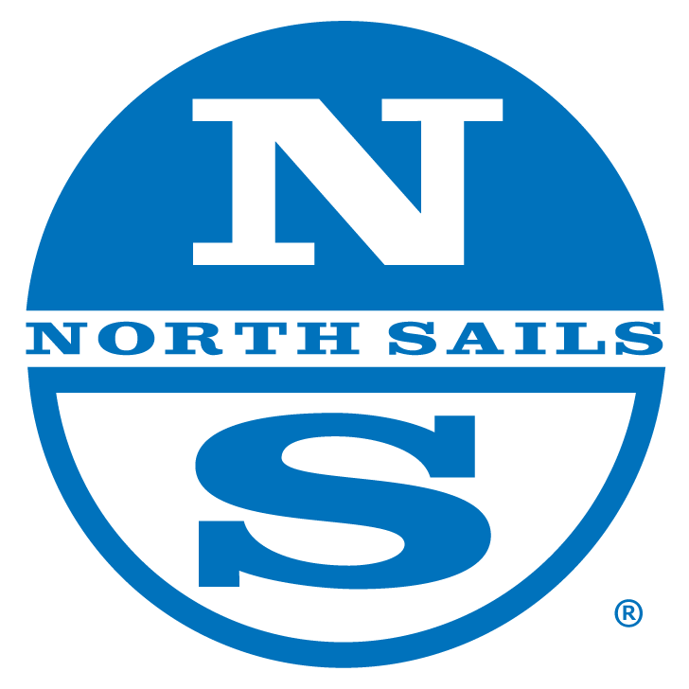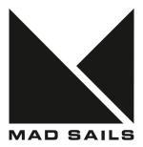

Event Map

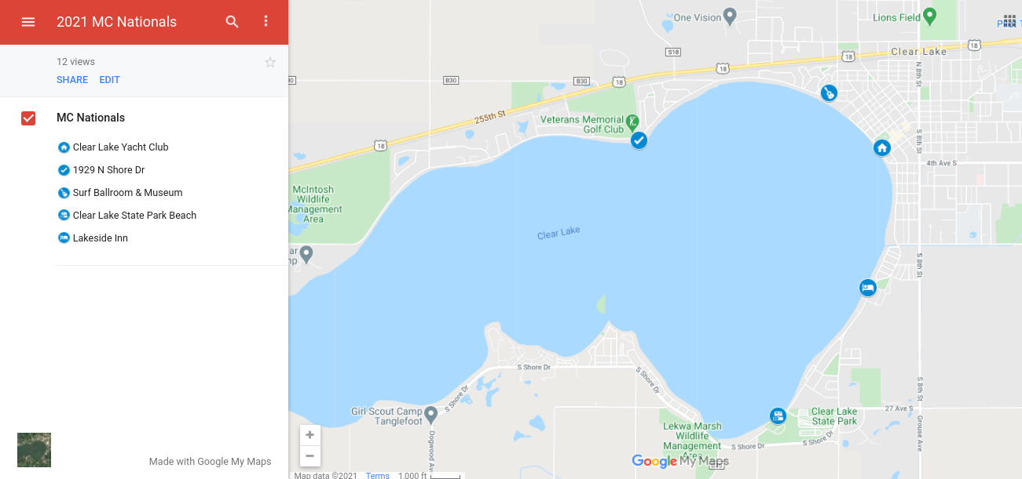

We can’t wait to see you in Clear Lake!
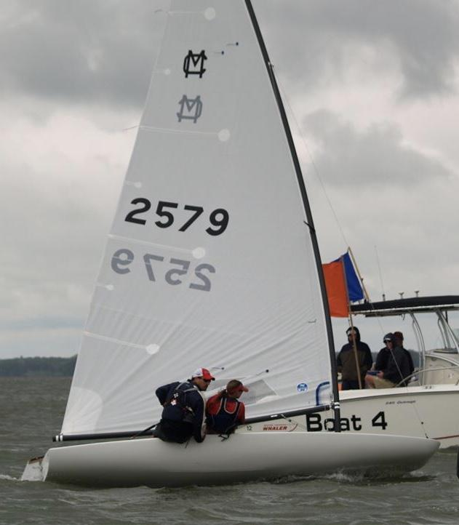
2013 National Championship at Clear Lake -Champions Kenny Wolfe and crew Virginia Hannan (Photo Credit MCSA)
Additional photo credits to: MCSA, CLYC, the Surf Ballroom, Dan Allen

